Milestone 1

CSC 261

Eustrat Zhupa

**Project details:**

Name of project: Library Database

Team: #18

Team members: Mark Xu, Zhenhao Zhang, Johnson Zhou

**Problem Statement:**

We aim to design and implement a concise library management system, including functions such as entry, search, borrowing, return, and library card management by their library cards.

This will be able to help librarians track book entries, updates, and organizations, and customers are also able to check the availability of books on their own through the website interface that we are going to design.

By implementing database management, we will reduce manual errors and improve accuracy. It also reduces labor cost, improves reliability, and allows complicated search filters, not only by the name of books but also by title, author, and ISBN etc..

**Target user:**​

Students and teachers can read the information in the database and search for books based on the following criteria: category, title, publisher, year (year range), author, and price (price range). They can check the book availability. But they can’t borrow the book by themselves, and they can’t modify the database.

Library employees will be able to read and modify the library database so that they can borrow and return books based on the students' and teachers' borrow-and-return activities. Moreover, they can add new books to the library database depending on the new inventory. This can help students and teachers find their resources.

The library super administrator has added their log-in page to the library management system.

**List of Relations:​**

Book (ISBN varchar (20) primary key, type varchar (20), name varchar (30), press varchar (20), year varchar (10), author varchar (30), price decimal (10, 2), total int, stock int, location varchar(50));

User (u_id char (20) primary key, name varchar (10), department varchar (40), type varchar (20));

Manager (m_id char (20) primary key, password char (64), name varchar (10), contact varchar (20));

Record (r_id char (20) primary key, ISBN varchar (20), u_id char (20), borrow_date_date, return_date_date, foreign key (ISBN) references Book, foreign key (u_id) references User);

Super_administrator (a_id char (20) primary key, password char (64), name varchar (10), contact varchar (20), department varchar (40));

**Web-interface:**

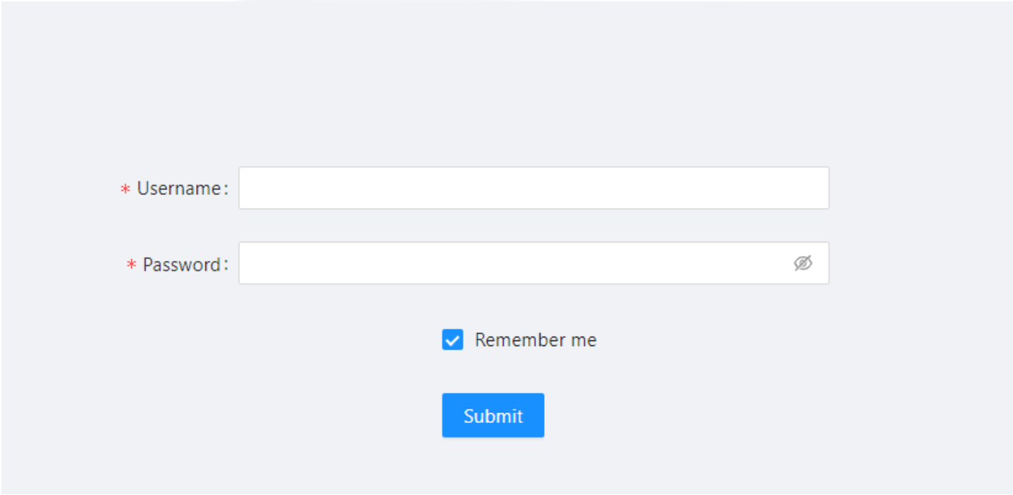

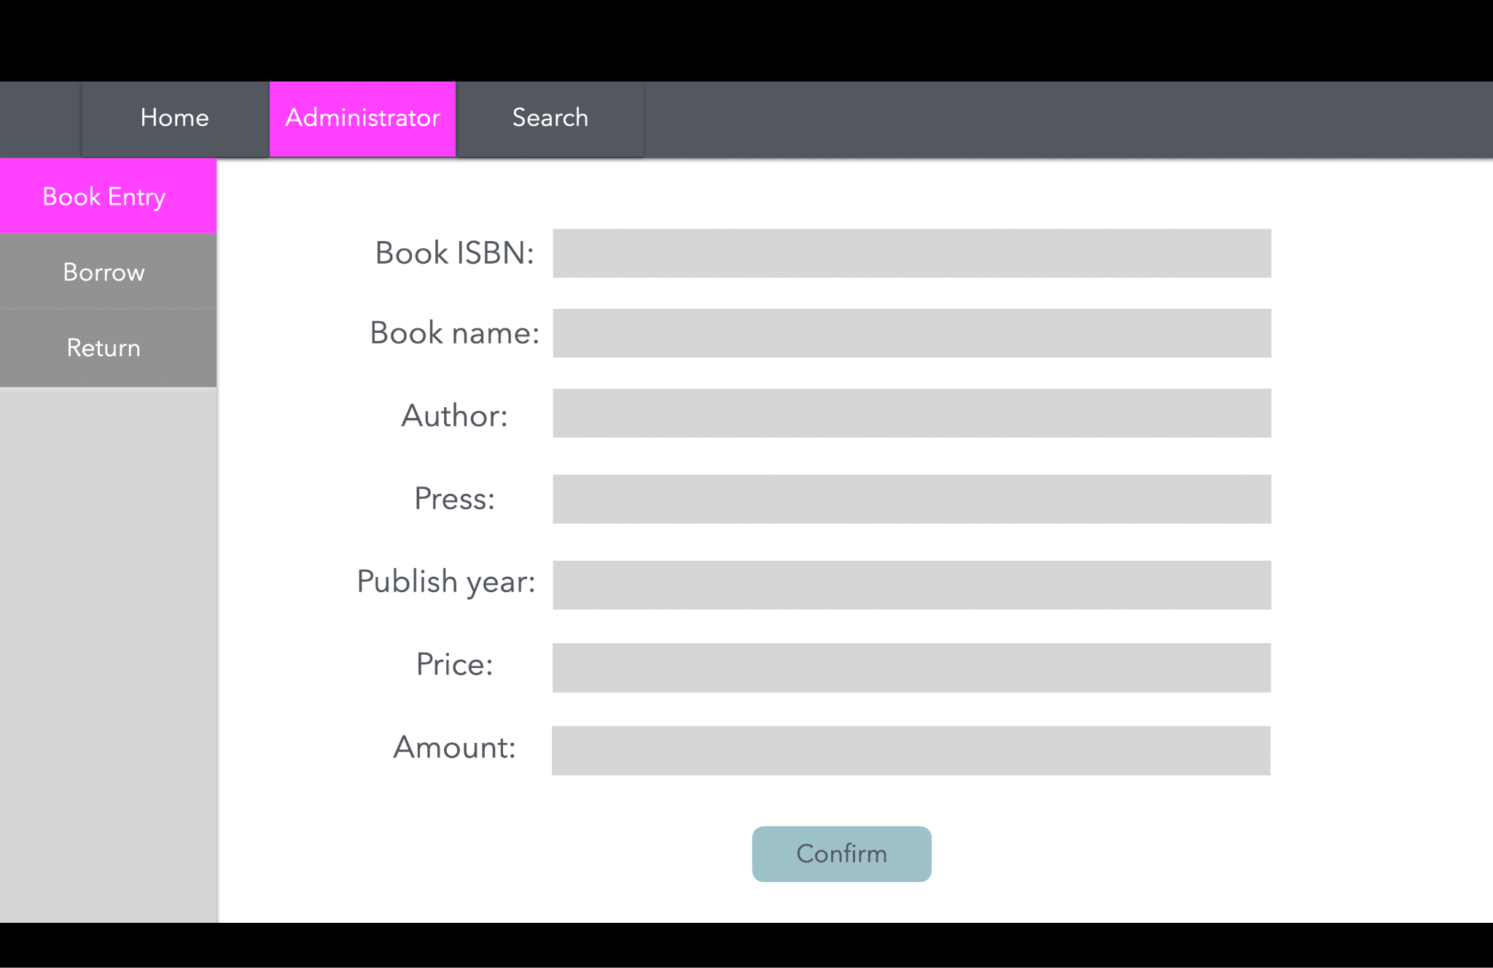

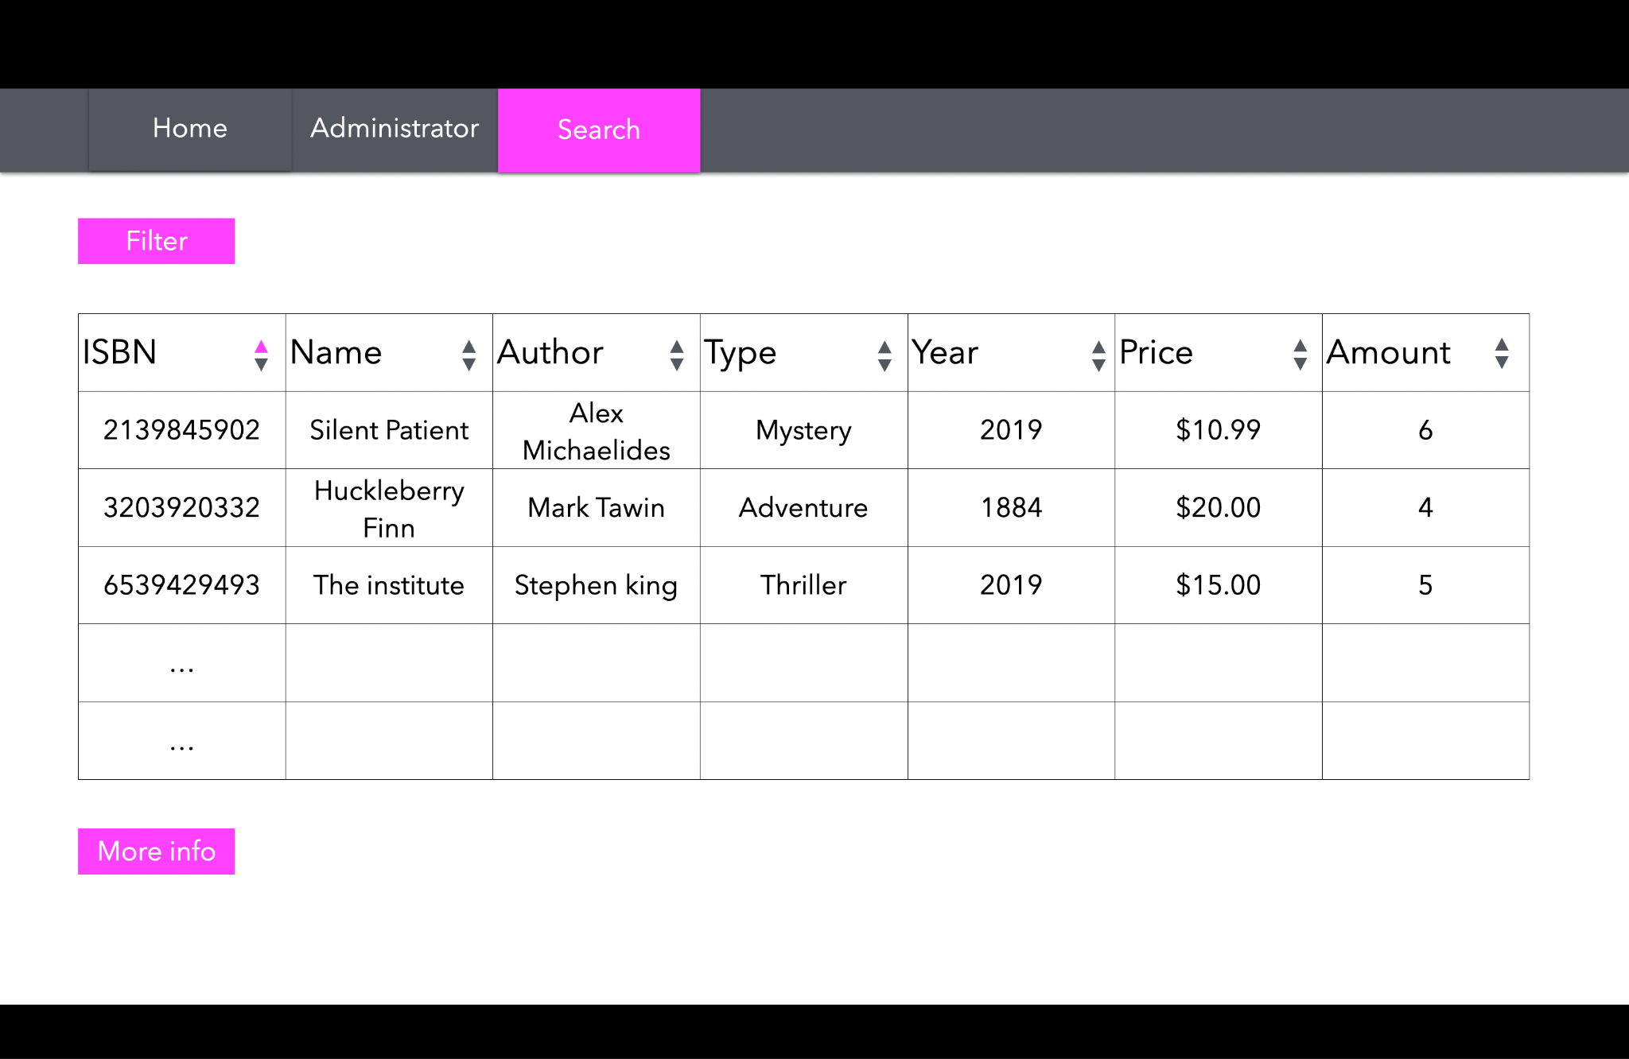

**Data:**

We are planning to obtain the database from external sources and modify it to fit our library database management needs.

Our resources:

<https://gist.github.com/apietrick24/bfffc6c0d47abf00029790381e89626d>

<https://www.kaggle.com/datasets/elvinrustam/books-dataset>

<https://www.kaggle.com/datasets/abdallahwagih/books-dataset>

​​